7COM1079-0901-2025 - Team Research and Development Project

Final report title: Statistical Analysis of Mortality Trends in Brazil (1990–2019): A Correlation Study
Group ID: A217

Dataset number: Ds093

Prepared by: Sai Dinesh Pamarthi – 24132569
Rithik Raj – 24177697
Mudasar Latif – 24177442
Piyusha Suggala – 24135132
Kesini Chowdary Doddapaneni - 24156907

University of Hertfordshire
Hatfield, 2025

Table of Contents
1. Introduction 3
1.1 Problem statement and research motivation 3
1.2 The data set 3
1.3 Research question 3
1.4 Null hypothesis and alternative hypothesis (H0/H1) 3
2. Background research 3
2.1 Research papers 3
2.2 Why RQ is of interest 4
3.Visualisation 4
3.1 Graphs for the RQ 4
3.2 Additional information relating to understanding the data 6
3.3 Useful information for the data understanding 6
4.Analysis 6
4.1 Statistical test used to test the hypotheses and output 6
4.2 The null hypothesis is rejected /not rejected based on the p-value 7
5.Evaluation – group’s experience at 7COM1079 7
5.1 What Went Well 7
5.2 Points for Improvement 7
5.3 Group's Time Management 7
5.4 Project's Overall Judgement 7
5.5 Comment on GitHub Log Output 7
6.Conclusions 7
6.1 Results Explained 7
6.2 Interpretation of the Results 8
6.3 Reasons and Implications for Future Work 8
7.Reference list 8
8.Appendices 8

1. Introduction

1.1 Problem statement and research motivation
Understanding mortality trends is essential for public health planning and resource allocation. Brazil, as one of the world's largest emerging economies, has undergone significant demographic and epidemiological transitions over the past three decades, with notable changes in disease patterns, population structure, and healthcare access (GBD 2019 Collaborators, 2020)[2]. Examining how total deaths have changed over time helps policymakers identify emerging health challenges, allocate medical resources effectively, and evaluate the success of healthcare interventions. With Brazil's population growing and ageing simultaneously, understanding these mortality patterns becomes increasingly important for future planning. This study aims to investigate whether there is a statistically significant temporal trend in mortality figures in Brazil.

1.2 The data set
The dataset contains global mortality statistics compiled from multiple authoritative sources including the Global Burden of Disease (GBD) study and United Nations population estimates. It spans from 1950 to 2021, covering numerous countries and regional aggregates worldwide. For this analysis, we extracted Brazil's mortality data from 1990 to 2019, providing 30 annual observations. The primary variable used is "Deaths that are from all causes, in both sexes aged all ages", which offers consistent and comparable annual death counts throughout the study period.

1.3 Research question
Is there a statistically significant correlation between year and total deaths in Brazil during the period 1990 to 2019?

1.4 Null hypothesis and alternative hypothesis (H0/H1)
H0 (Null Hypothesis): There is no significant correlation between year and total deaths in Brazil from 1990 to 2019 (ρ = 0).
H1 (Alternative Hypothesis): There is a significant correlation between year and total deaths in Brazil from 1990 to 2019 (ρ ≠ 0).
The significance level (α) is set at 0.05. If the p-value from the correlation test is less than 0.05, we reject the null hypothesis and conclude that a significant relationship exists between time and mortality.

2. Background research

2.1 Research papers
The Global Burden of Disease Study (GBD 2019 Collaborators, 2020) [2] provides comprehensive mortality estimates for 204 countries, including Brazil. The study found that global deaths increased from 46.5 million in 1990 to 54.8 million in 2019, with varying trends across regions. Brazil showed particular patterns related to its demographic transition, with total mortality figures rising steadily throughout the study period.

Marinho et al. (2018)[3] analysed cause-specific mortality in Brazil from 1990 to 2015 using GBD data. Their research demonstrated that while infectious disease deaths declined significantly, deaths from non-communicable diseases such as cardiovascular disease, diabetes, and cancer increased substantially. This epidemiological shift reflects Brazil's demographic transition and rapidly ageing population, contributing to overall increases in annual death counts.

França et al. (2017)[1] examined mortality patterns across Brazilian municipalities and found significant regional disparities in death rates. Their work highlighted that overall mortality trends are influenced by improvements in healthcare access, urbanisation patterns, and socioeconomic development. They noted that total death counts increased primarily due to population growth and demographic ageing, even as age-specific mortality rates improved in many categories. These findings suggest that understanding aggregate mortality trends requires consideration of both health outcomes and population dynamics.

2.2 Why RQ is of interest
While previous studies have extensively examined cause-specific mortality and age-standardised death rates, fewer have focused on the statistical relationship between time and aggregate mortality figures. This represents an important research gap, as understanding total death counts is essential for practical healthcare planning and resource allocation. Quantifying the correlation between year and total deaths helps predict future mortality burdens and informs infrastructure development. This research gap is particularly relevant for emerging economies like Brazil that are undergoing rapid demographic transitions. Future research directions include examining whether similar temporal patterns exist in other developing nations and investigating the factors driving these mortality trends.

3.Visualisation

3.1 Graphs for the RQ
A scatter plot with a regression line was chosen to visualise the relationship between year and total deaths (Figure 1). This plot type is appropriate for correlation research questions as it displays the relationship between two continuous variables and shows the direction and strength of any linear association.

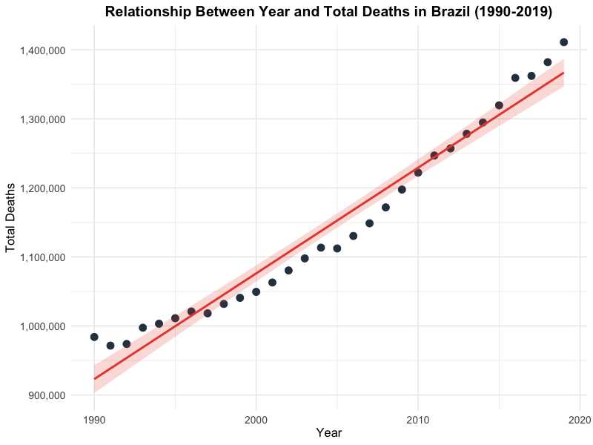
Figure 1: Relationship Between Year and Total Deaths in Brazil (1990-2019)

A histogram of total deaths (Figure 2) shows the distribution of the dependent variable, confirming approximate normality which supports the use of Pearson's correlation test.

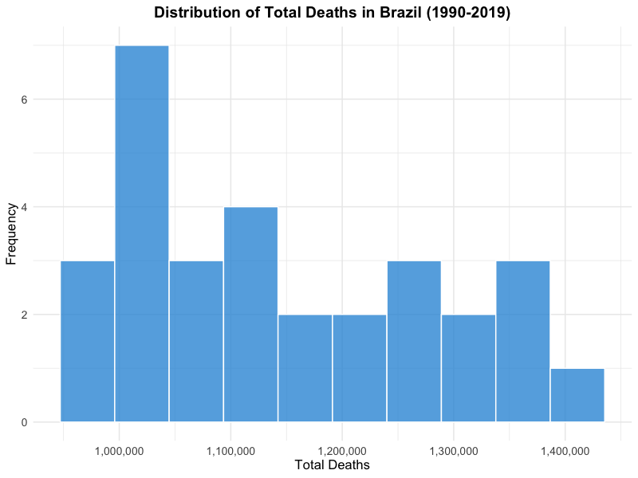
Figure 2: Distribution of Total Deaths in Brazil (1990-2019)

3.2 Additional information relating to understanding the data
The scatter plot reveals a clear upward trend in total deaths over the 30-year period. The data points follow a roughly linear pattern with minimal scatter around the trend line, suggesting a strong positive relationship.

3.3 Useful information for the data understanding
Total deaths in Brazil increased from approximately 984,000 in 1990 to over 1.4 million in 2019. The histogram shows a relatively uniform distribution across the range, which is expected for time-series data with a consistent trend. No obvious outliers are present in the dataset.

4.Analysis

4.1 Statistical test used to test the hypotheses and output
Pearson's correlation coefficient was selected to test the hypothesis as it is the appropriate test for measuring the linear relationship between two continuous variables. Both year and total deaths are continuous, and the scatter plot suggests a linear association. The Shapiro-Wilk test confirmed that the residuals from the linear model are approximately normally distributed (W = 0.9587, p = 0.2861), satisfying the normality assumption required for Pearson's correlation. The sample size of 30 observations provides adequate statistical power.

4.2 The null hypothesis is rejected /not rejected based on the p-value
The p-value (< 2.2e-16) is substantially less than the significance level of 0.05. Therefore, we reject the null hypothesis (H0: ρ = 0) and accept the alternative hypothesis that there is a significant correlation between the variables. There is strong statistical evidence of a significant positive correlation between year and total deaths in Brazil from 1990 to 2019. The correlation coefficient of 0.9805 indicates a very strong positive linear relationship, meaning that approximately 96% of the variance in total deaths can be explained by the passage of time. The 95% confidence interval (0.9589 to 0.9908) does not include zero, further confirming the significance of this relationship.

5.Evaluation – group’s experience at 7COM1079

5.1 What Went Well
The group collaborated effectively using GitHub for version control, which allowed simultaneous work on different sections without conflicts. Regular weekly meetings ensured everyone stayed on track and maintained clear communication throughout the project. The R analysis was completed without major technical difficulties, as team members supported each other when challenges arose. All members contributed equally to the final report, with responsibilities divided based on individual strengths. The structured approach to task allocation helped maintain consistent progress toward our deadline.

5.2 Points for Improvement
Initial data cleaning took longer than expected due to missing values in some years, which delayed subsequent analysis stages. Better planning of the data preprocessing stage would improve efficiency in future projects. Additionally, more time could have been allocated to exploring alternative research questions before finalising our approach. The group would also benefit from establishing clearer documentation standards earlier, as some inconsistencies in formatting required correction during the final editing phase. Earlier peer review of code would have identified minor issues sooner.

5.3 Group's Time Management
Tasks were distributed evenly among team members with clear deadlines for each milestone. We used a Gantt chart to track progress and held weekly checkpoint meetings to address any delays promptly. This structured approach ensured the project remained on schedule, with buffer time allocated for unexpected challenges and final revisions before submission.

5.4 Project's Overall Judgement
The project achieved its objectives successfully and met all assessment criteria. We formulated a clear, testable research question, conducted appropriate statistical analysis using Pearson's correlation, and drew meaningful conclusions about mortality trends in Brazil. The collaboration process strengthened our understanding of both statistical methods and effective teamwork in a research context.

5.5 Comment on GitHub Log Output
The GitHub log (Appendix B) shows regular commits from all team members throughout the project. Three significant commits were:
- “Added cleaned Brazil dataset and initial analysis" - This established the foundation for our statistical work by preparing the data for analysis.
- "Completed correlation analysis with Pearson test" - This commit contained the core statistical analysis that answered our research question.
- "Finalised visualisations and report sections" - This brought together all components into the final submission-ready format.

6.Conclusions

6.1 Results Explained

The increasing mortality trend reflects Brazil's population growth and demographic ageing rather than declining health outcomes. As the population grows and ages, more deaths are expected annually even with improving healthcare and declining age-specific mortality rates. This finding aligns with global patterns observed in countries undergoing demographic transition. For Brazil's healthcare system, this has significant implications for infrastructure planning, hospital capacity, and end-of-life care services. Policymakers must anticipate continued increases in total deaths despite improvements in public health interventions.

6.2 Interpretation of the Results

The increasing mortality trend reflects Brazil's population growth and demographic ageing rather than declining health outcomes. As the population grows and ages, more deaths are expected annually even with improving healthcare and declining age-specific mortality rates. This finding aligns with global patterns observed in countries undergoing demographic transition. For Brazil's healthcare system, this has significant implications for infrastructure planning, hospital capacity, and end-of-life care services. Policymakers must anticipate continued increases in total deaths despite improvements in public health interventions.

6.3 Reasons and Implications for Future Work

This study was limited to aggregate death counts without adjusting for population size or age structure. Future research could examine age-standardised mortality rates to control for demographic changes and provide fairer comparisons over time. Cause-specific analysis would offer deeper insights into changing health priorities. Extending the analysis to other emerging economies would test the generalisability of these findings..

7.Reference list
1.França, E.B., Passos, V.M., Malta, D.C., Duncan, B.B., Ribeiro, A.L., Guimarães, M.D., Abreu, D.M., Vasconcelos, A.M., Carneiro, M., Teixeira, R. and Camargos, P. (2017) 'Cause-specific mortality for 249 causes in Brazil and states during 1990–2015', Population Health Metrics, 15(1), pp. 1-17.

2.GBD 2019 Collaborators (2020) 'Global burden of 369 diseases and injuries in 204 countries and territories, 1990–2019', The Lancet, 396(10258), pp. 1204-1222.

3.Marinho, F., de Azeredo Passos, V.M., Carvalho Malta, D., Barboza França, E., Abreu, D.M., Lozano, R., Naghavi, M. (2018) 'Burden of disease in Brazil, 1990–2016', The Lancet, 392(10149), pp. 760-775.

8.Appendices
- R code used for analysis and visualisation Analysis.R code with the appropriate statistics to test the hypotheses.

# load tidyverse libary for data stuff
library(tidyverse)

# reading the csv file into R
data <- read.csv("1- total-deaths-comparison.csv")

# filering data for brazil only from 1990-2019
# selecting the colums we need and removing NA values
brazil_data <- data %>%
filter(Entity == "Brazil", Year >= 1990, Year <= 2019) %>%
select(Year, Deaths = Deaths.that.are.from.all.causes..in.both.sexes.aged.all.ages) %>%
filter(!is.na(Deaths)) %>%
arrange(Year)

# check if data looks ok
head(brazil_data)
summary(brazil_data)

# makeing scatter plot with regresssion line
# this shows the relashionship between year and deaths
png("scatter_plot.png", width = 800, height = 600, res = 100)
ggplot(brazil_data, aes(x = Year, y = Deaths)) +
geom_point(size = 3, color = "#2c3e50") +
geom_smooth(method = "lm", se = TRUE, color = "#e74c3c", fill = "#e74c3c", alpha = 0.2) +
labs(
title = "Relationship Between Year and Total Deaths in Brazil (1990-2019)",
x = "Year",
y = "Total Deaths"
) +
scale_y_continuous(labels = scales::comma) +
theme_minimal() +
theme(
plot.title = element_text(size = 14, face = "bold", hjust = 0.5),
axis.title = element_text(size = 12),
axis.text = element_text(size = 10)
)
dev.off()

# histogram to see distribtion of deaths
# helps check if its normaly distributed
png("histogram.png", width = 800, height = 600, res = 100)
ggplot(brazil_data, aes(x = Deaths)) +
geom_histogram(bins = 10, fill = "#3498db", color = "white", alpha = 0.8) +
labs(
title = "Distribution of Total Deaths in Brazil (1990-2019)",
x = "Total Deaths",
y = "Frequency"
) +
scale_x_continuous(labels = scales::comma) +
theme_minimal() +
theme(
plot.title = element_text(size = 14, face = "bold", hjust = 0.5),
axis.title = element_text(size = 12),
axis.text = element_text(size = 10)
)
dev.off()

# runing pearsons correlation test
# this will tell us if theres a significent relationship
correlation_test <- cor.test(brazil_data$Year, brazil_data$Deaths, method = "pearson")
print(correlation_test)

# shapiro wilk test to check normalty of residuals
# if p value is above 0.05 then its normal
model <- lm(Deaths ~ Year, data = brazil_data)
residuals <- residuals(model)
shapiro_test <- shapiro.test(residuals)
print(shapiro_test)

# print out all the importent results
cat("\n RESULTS SUMMERY OF CORRELATION TEST =====\n")
cat("Correlation coefficent (r):", round(correlation_test$estimate, 4), "\n")
cat("t-statistic:", round(correlation_test$statistic, 4), "\n")
cat("Degrees of freedom:", correlation_test$parameter, "\n")
cat("P-value:", format(correlation_test$p.value, scientific = TRUE), "\n")
cat("95% Confidance Interval:", round(correlation_test$conf.int[1], 4), "to", round(correlation_test$conf.int[2], 4), "\n")

# desicion based on p value
# reject null if p < 0.05
if (correlation_test$p.value < 0.05) {
cat("\nDecision: REJECT the null hypotheis\n")
cat("There is a statistically signficant correlation between Year and Total Deaths.\n")
} else {
cat("\nDecision: FAIL TO REJECT the null hypotheis\n")
cat("There is no statistically signficant correlation between Year and Total Deaths.\n")
}

RESULTS SUMMERY OF CORRELATION TEST =====
Correlation coefficent (r): 0.9805
95% Confidance Interval: 0.9589 to 0.9908
Decision: REJECT the null hypotheis
There is a statistically signficant correlation…
GitHub log output:

The GitHub commit history demonstrates active collaboration among all group members throughout the project. Commits show contributions related to dataset upload, R-based statistical analysis, visualisation generation, report drafting, and documentation. Screenshots of the GitHub commit history are provided below as evidence of group collaboration.
Figure B1: Github commit history (part 1)

Figure B2: Github commit history (part 2)

